- Before registering, please ensure you have stopped any previous direct debits or standing orders for team fees. When registering you will require to complete a Direct Debit for the monthly membership fee.

- You will receive an email from registration@myclub-hub.com, click on the link to take you to the registration page

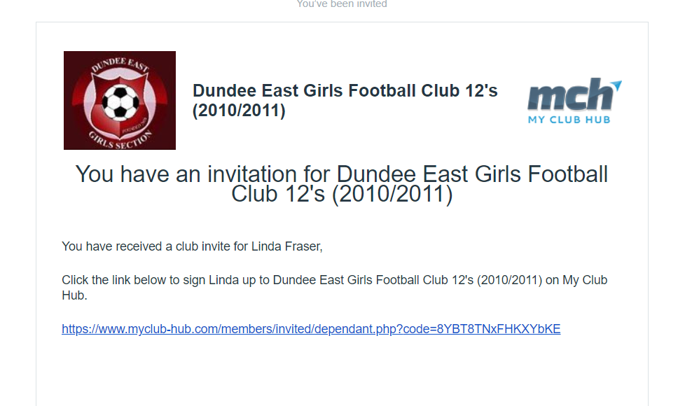
- This will take you to the main registration page. 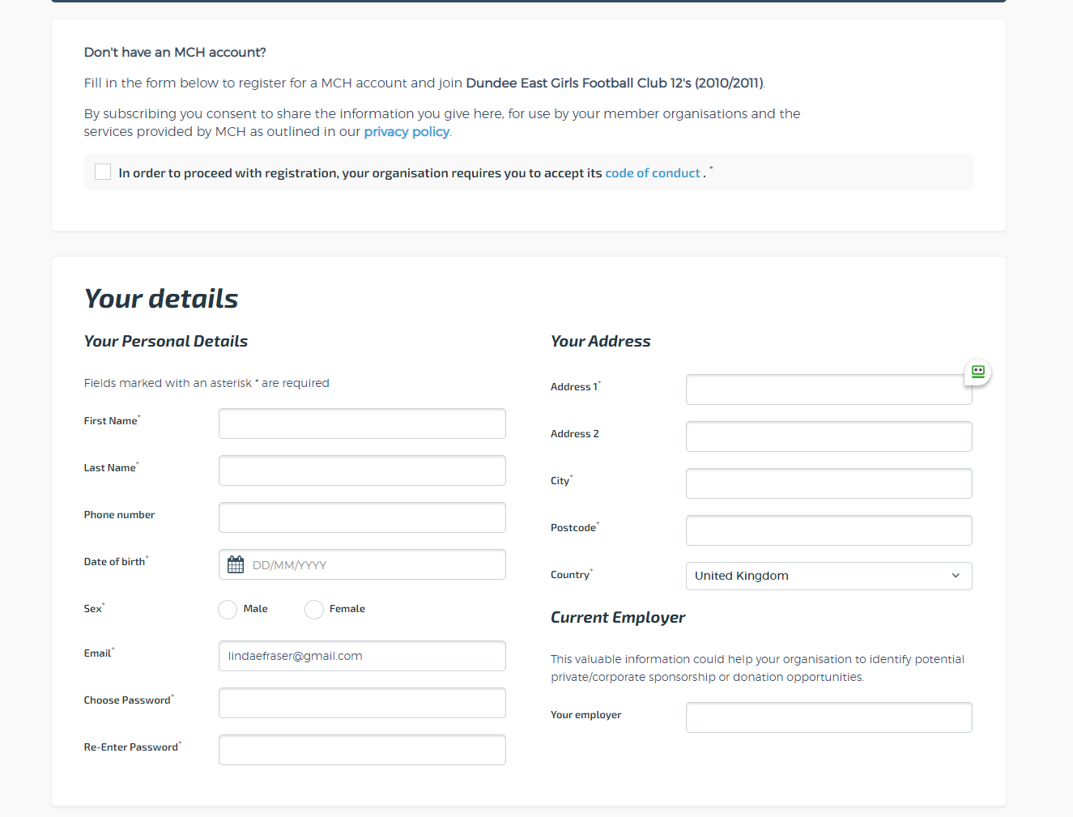
  - Please read the Players and parents code of contact prior to starting your registration as registering you and your daughter are acknowledging this code of contact.
  - Any fields marked with a star(*) are compulsory fields and must be completed
  - Your email address and the password you enter will be your username/password to access the MyClubHUb app/website for messaging, updating your details and fixtures and club/team news.

- Next enter your daughters’ details
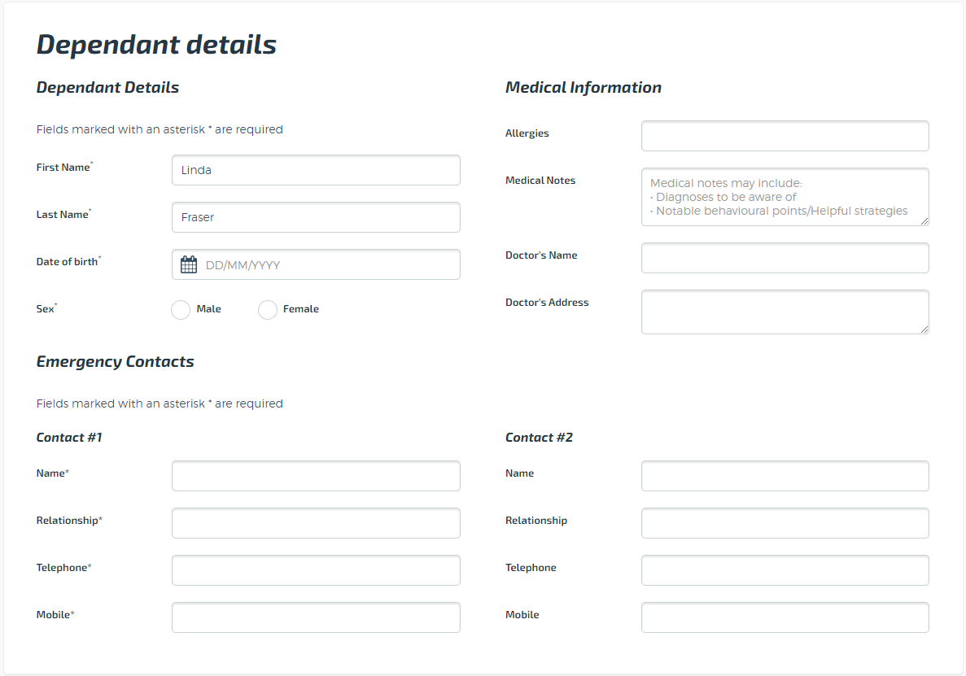
- Next complete the parental consents, please only tick the boxes where you consent.
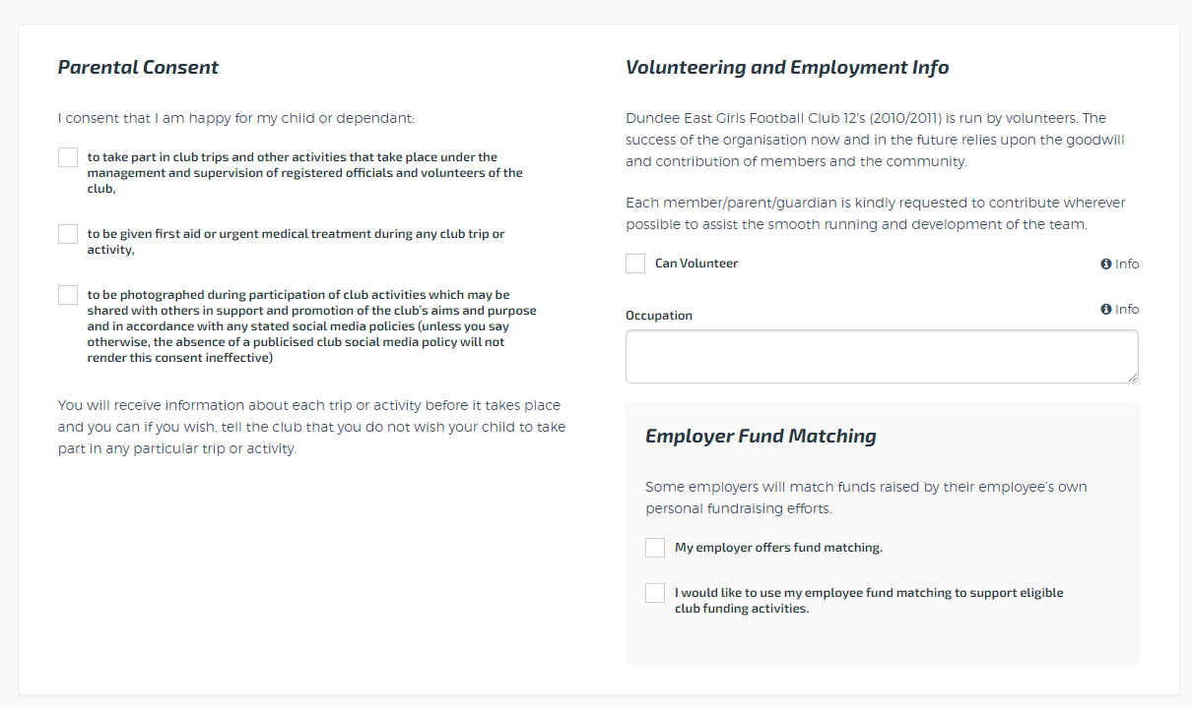
If you are open to volunteering on occasion or volunteering for a specific role please tick the “Can Volunteer” box. Please use the occupation box to add comment around where or what role you would be happy volunteering for
- Finally once all of the above form has been completed, click on the setup payments button in the payments section
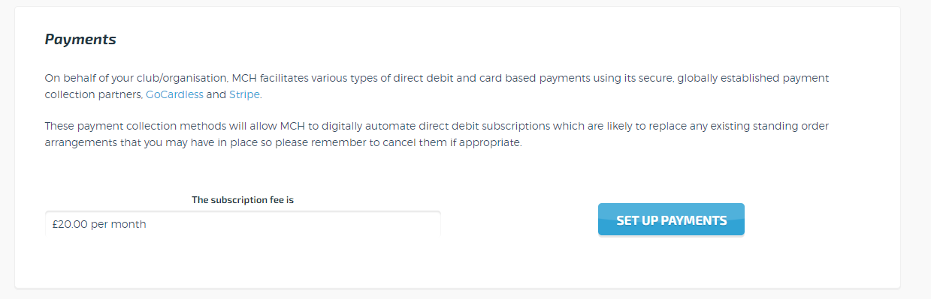
This then opens up the gocardless direct debit page
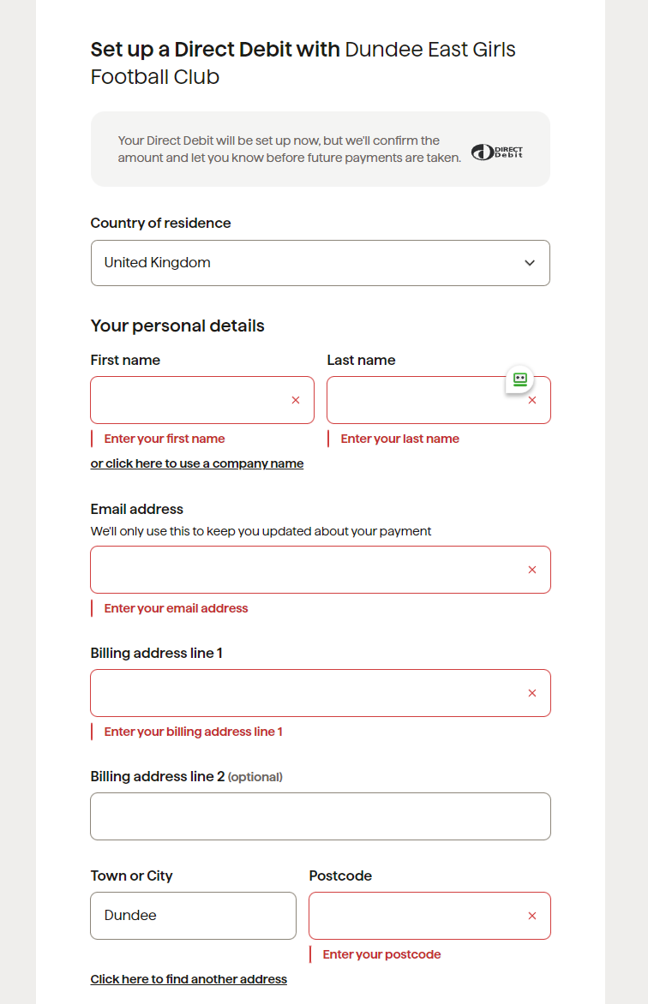
Once completed and direct debit info submitted, you are taken to your myclubhub page
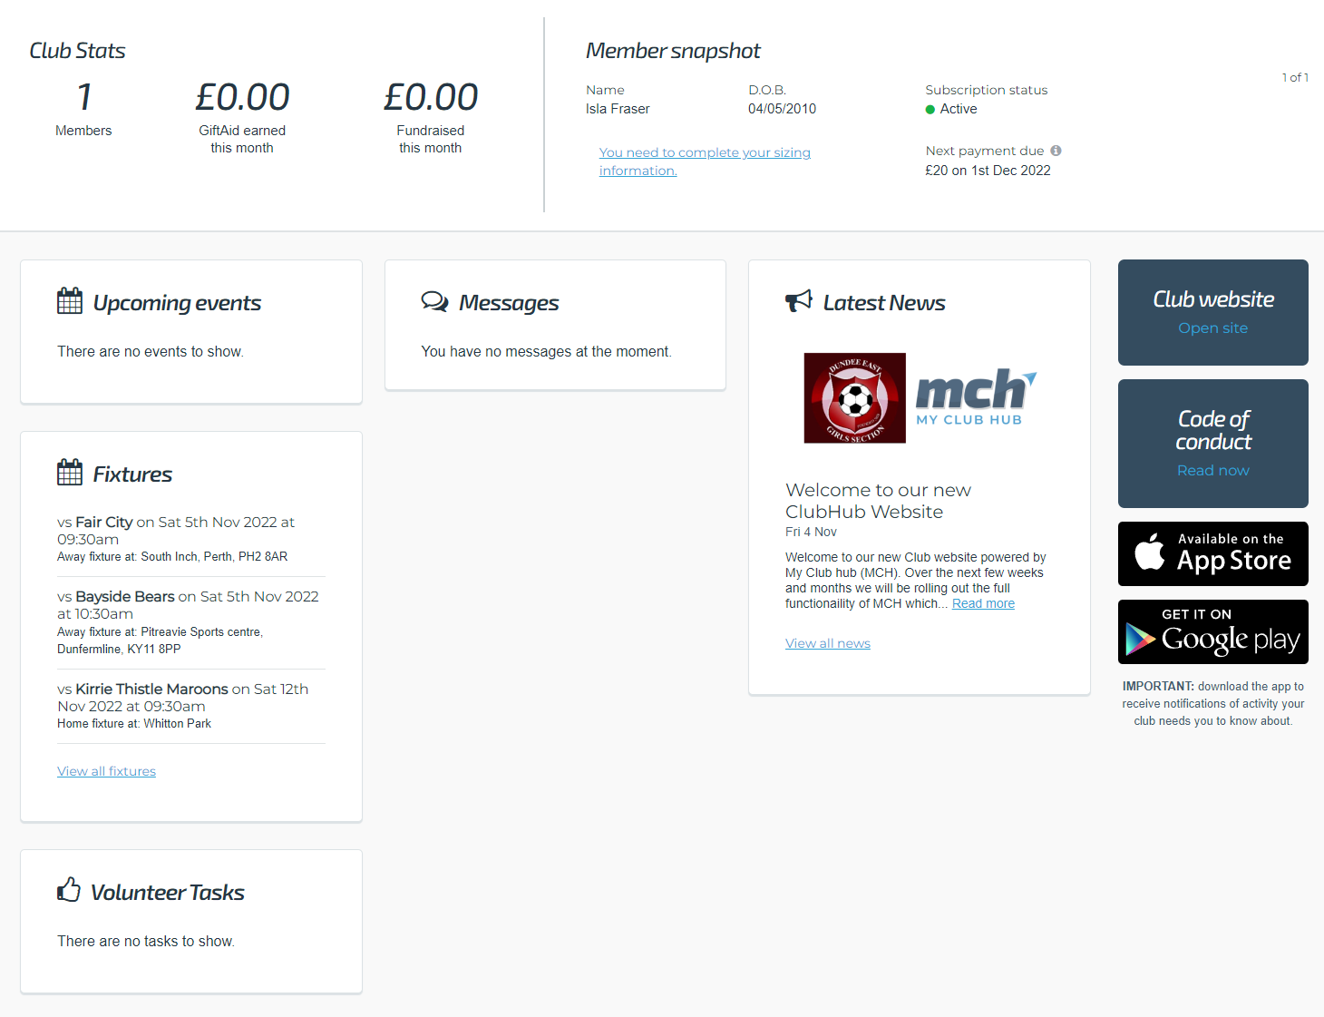

Please click on the blue highlighted link to add the girls sizing information
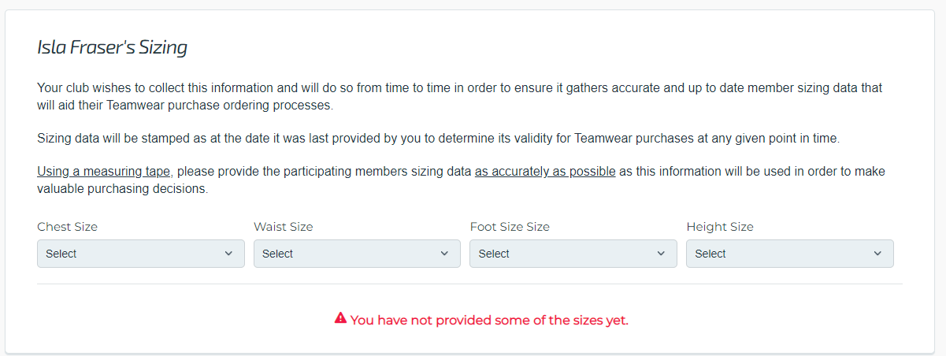

The dashboard will show any messages for the parents, upcoming fixtures for your daughters particular team, and a link to the public website for the team.

As we roll out this system we will move all messaging in relation to teams, matches and training onto this platform from whatsapp. You can download the MCH app for IOS or android for easier access and message notifications

By clicking on your name in the top right hand corner and clicking my account , you then can edit any of you or your daughters profile information
By clicking on settings you can chose what notifications you receive from the club by email or through the MCH app

If you choose to leave the club you can log in and under manage members, scroll down and click on cancel subscription to cancel the direct debit. If you need to change bank details this can also be done on this page.

